**Created By :**

Lakhani Dinky A. IT062

Modi Aastha N. IT079

Gurvinder Singh P. IT084

**Under the guidance of :**

Prof. Archana N Vyas

Prof Fatema Vhora

**Sem :** 5

**Batch :** H3

**Topic :** OmniLib

**Subject :** Database Management System

**Univ. :** Dharmsinh Desai University

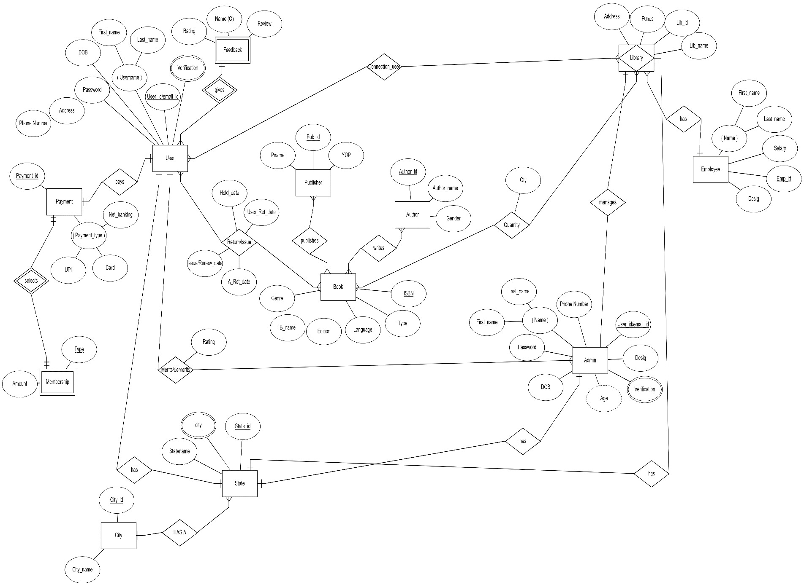

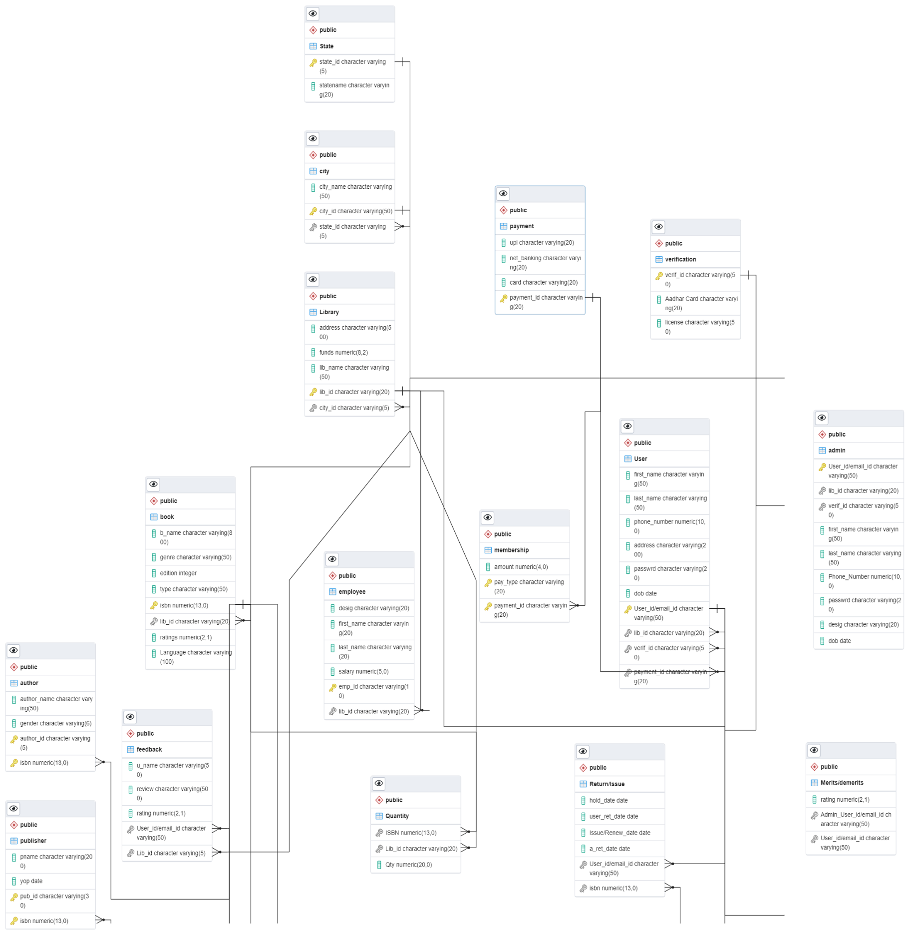

**Queries for Table Creation**

**CREATE SCHEMA**

**1)----------------Verification---------------------------------**

CREATE TABLE Verification

(

Verif_id varchar(50) NOT NULL,

"Aadhar Card" varchar(20) NULL,

License varchar(50) NULL,

CONSTRAINT PK_215 PRIMARY KEY ( Verif_id )

);

**2)----------------State----------------------------------------------**

CREATE TABLE "State"

(

State_id varchar(5) NOT NULL,

Statename varchar(50) NOT NULL,

CONSTRAINT PK_159 PRIMARY KEY ( State_id ));

**3)----------------City-----------------------------------------**

CREATE TABLE City

(

City_name varchar(50) NOT NULL,

City_id varchar(50) NOT NULL,

State_id varchar(5) NOT NULL,

CONSTRAINT PK_163 PRIMARY KEY ( City_id),

CONSTRAINT FK_165 FOREIGN KEY ( State_id ) REFERENCES "State" ( State_id )

);

CREATE INDEX fkIdx_167 ON City

(

State_id

);

**4)----------------Library----------------------------------------**

CREATE TABLE "Library"

(

Address varchar(500) NOT NULL,

Funds numeric(8,2) NOT NULL,

Lib_name varchar(50) NOT NULL,

Lib_id varchar(20) NOT NULL,

City_id varchar(5) NOT NULL,

CONSTRAINT PK_52 PRIMARY KEY ( Lib_id),

CONSTRAINT FK_181 FOREIGN KEY ( City_id ) REFERENCES "State" ( City_id )

);

CREATE INDEX fkIdx_183 ON "Library"

(

City_id

);

**5)----------------Admin---------------------------------------**

CREATE TABLE Admin

(

"User_id/email_id" varchar(50) NOT NULL,

Lib_id varchar(20) NOT NULL,

Verif_id varchar(50) NOT NULL,

First_name varchar(50) NOT NULL,

Last_name varchar(50) NOT NULL,

"Phone_Number" numeric(10,0) NOT NULL,

Passwrd varchar(20) NOT NULL,

Desig varchar(20) NOT NULL,

DOB date NOT NULL,

CONSTRAINT PK_191 PRIMARY KEY ( "User_id/email_id"),

CONSTRAINT FK_121 FOREIGN KEY ( Lib_id) REFERENCES "Library" ( Lib_id),

CONSTRAINT FK_231 FOREIGN KEY ( Verif_id ) REFERENCES Verification ( Verif_id )

);

CREATE INDEX fkIdx_124 ON Admin

(

Lib_id

);

CREATE INDEX fkIdx_233 ON Admin

(

Verif_id

);

**6)----------------Employee----------------------------------**

CREATE TABLE Employee

(

Desig varchar(20) NOT NULL,

First_name varchar(20) NOT NULL,

Last_name varchar(20) NOT NULL,

Salary numeric(5,0) NOT NULL,

Emp_id varchar(10) NOT NULL,

Lib_id varchar(20) NOT NULL,

CONSTRAINT PK_187 PRIMARY KEY ( Emp_id),

CONSTRAINT FK_56 FOREIGN KEY ( Lib_id) REFERENCES "Library" ( Lib_id)

);

CREATE INDEX fkIdx_58 ON Employee

(

Lib_id

);

**7)----------------Book-------------------------------------------**

CREATE TABLE Book

(

B_name varchar(800) NOT NULL,

Genre varchar(50) NOT NULL,

Edition int NOT NULL,

Type varchar(50) NOT NULL,

ISBN decimal(13,0) NOT NULL,

Lib_id varchar(20) NOT NULL,

Ratings numeric(2,1) NOT NULL,

Language varchar(100) NULL,

CONSTRAINT PK_185 PRIMARY KEY ( ISBN ),

CONSTRAINT FK_59 FOREIGN KEY ( Lib_id) REFERENCES "Library" ( Lib_id)

);

CREATE INDEX fkIdx_61 ON Book

(

Lib_id

);

**8)----------------Publisher------------------------------------------**

CREATE TABLE Publisher

(

Pname varchar(20) NOT NULL,

YOP date NOT NULL,

Pub_id varchar(20) NOT NULL,

ISBN decimal(13,0) NOT NULL,

CONSTRAINT PK_193 PRIMARY KEY ( Pub_id,ISBN),

CONSTRAINT FK_15 FOREIGN KEY ( ISBN) REFERENCES Book (ISBN)

);

CREATE INDEX fkIdx_17 ON Publisher

(

ISBN

);

**9)----------------Author--------------------------------------**

CREATE TABLE Author

(

Author_name varchar(50) NOT NULL,

Gender varchar(6) NOT NULL,

Author_id varchar(5) NOT NULL,

ISBN decimal(13,0) NOT NULL,

CONSTRAINT PK_195 PRIMARY KEY ( Author_id,ISBN),

CONSTRAINT FK_23 FOREIGN KEY ( ISBN) REFERENCES Book ( ISBN)

);

CREATE INDEX fkIdx_25 ON Author

(

ISBN

);

**10)----------------Payment-------------------------------------**

CREATE TABLE Payment

(

UPI varchar(20) NULL,

Net_Banking varchar(20) NULL,

Card varchar(20) NULL,

Payment_id varchar(20) NOT NULL,

CONSTRAINT PK_230 PRIMARY KEY ( Payment_id )

);

**11)----------------Membership-----------------------------**

CREATE TABLE Membership

(

Amount numeric(4,0) NOT NULL,

Pay_Type varchar(20) NOT NULL,

Payment_id varchar(20) NOT NULL,

CONSTRAINT PK_222 PRIMARY KEY ( Pay_Type, Payment_id ),

CONSTRAINT FK_237 FOREIGN KEY ( Payment_id ) REFERENCES Payment ( Payment_id )

);

CREATE INDEX fkIdx_239 ON Membership

(

Payment_id

);

**12)----------------User--------------------------------------**

CREATE TABLE "User"

(

First_name varchar(50) NOT NULL,

Last_name varchar(50) NOT NULL,

Phone_Number numeric(10,0) NOT NULL,

Address varchar(200) NOT NULL,

Passwrd varchar(20) NOT NULL,

DOB date NOT NULL,

"User_id/email_id" varchar(50) NOT NULL,

Lib_id varchar(20) NOT NULL,

Verif_id varchar(50) NOT NULL,

Payment_id varchar(20) NOT NULL,

CONSTRAINT PK_189 PRIMARY KEY ( "User_id/email_id"),

CONSTRAINT FK_131 FOREIGN KEY ( Lib_id) REFERENCES "Library" ( Lib_id),

CONSTRAINT FK_218 FOREIGN KEY ( Verif_id ) REFERENCES Verification ( Verif_id ),

CONSTRAINT FK_240 FOREIGN KEY ( Payment_id ) REFERENCES Payment ( Payment_id )

);

CREATE INDEX fkIdx_133 ON "User"

(

Lib_id

);

CREATE INDEX fkIdx_220 ON "User"

(

Verif_id

);

CREATE INDEX fkIdx_242 ON "User"

(

Payment_id

);

**13)----------------Return/Issue--------------------------------**

CREATE TABLE "Return/Issue"

(

Hold_date date NOT NULL,

User_Ret_date date NOT NULL,

"Issue/Renew_date" date NOT NULL,

A_Ret_date date NOT NULL,

"User_id/email_id" varchar(50) NOT NULL,

ISBN decimal(13,0) NOT NULL,

CONSTRAINT FK_102 FOREIGN KEY ( "User_id/email_id") REFERENCES "User" ( "User_id/email_id"),

CONSTRAINT FK_106 FOREIGN KEY ( ISBN) REFERENCES Book ( ISBN)

);

CREATE INDEX fkIdx_104 ON "Return/Issue"

(

"User_id/email_id"

);

CREATE INDEX fkIdx_110 ON "Return/Issue"

(

ISBN

);

**14)----------------Feedback----------------------------------------**

CREATE TABLE Feedback

(

U_name varchar(50) NULL,

Review varchar(500) NOT NULL,

Rating numeric(2,1) NOT NULL,

"User_id/email_id" varchar(50) NOT NULL,

Lib_id varchar(5) NULL,

CONSTRAINT FK_75 FOREIGN KEY ( "User_id/email_id") REFERENCES "User" ( "User_id/email_id")

CONSTRAINT FK_111 FOREIGN KEY ( "Lib_id") REFERENCES "Library" ( "Lib_id ")

);

CREATE INDEX fkIdx_77 ON Feedback

(

"User_id/email_id"

);

**15)----------------Merits/Demerits------------------------------**

CREATE TABLE "Merits/demerits"

(

Rating numeric(2,1) NOT NULL,

"Admin_User_id/email_id" varchar(50) NOT NULL,

"User_id/email_id" varchar(50) NOT NULL,

CONSTRAINT FK_144 FOREIGN KEY ( "Admin_User_id/email_id") REFERENCES Admin ( "User_id/email_id"),

CONSTRAINT FK_153 FOREIGN KEY ( "User_id/email_id") REFERENCES "User" ( "User_id/email_id")

);

CREATE INDEX fkIdx_147 ON "Merits/demerits"

(

"Admin_User_id/email_id"

);

CREATE INDEX fkIdx_156 ON "Merits/demerits"

(

"User_id/email_id"

);

**16)---------------Quantity------------------------**

CREATE TABLE public."Quantity"

(

"ISBN" numeric(13, 0) NOT NULL,

"Lib_id" character varying(20) NOT NULL,

"Qty" numeric(20, 0) NOT NULL

);

ALTER TABLE Quantity"

ADD FOREIGN KEY ("ISBN")

REFERENCES book (isbn);

ALTER TABLE "Quantity"

ADD FOREIGN KEY ("Lib_id")

REFERENCES Library" (lib_id);

**_______________________________________________________________________________________________________**

**Insert Table Queries**

**1)State Table**

Insert into "State" values('S2','Arunachal Pradesh');

Insert into "State" values('S3','Assam');

Insert into "State" values('S4','Bihar');

Insert into "State" values('S5','Chhattisgarh');

Insert into "State" values('S6','Goa');

Insert into "State" values('S7','Gujarat');

Insert into "State" values('S8','Haryana');

Insert into "State" values('S9','Himachal Pradesh');

Insert into "State" values('S10','Jharkhand');

Insert into "State" values('S11','Karnataka');

Insert into "State" values('S12','Kerala');

Insert into "State" values('S13','Madhya Pradesh');

Insert into "State" values('S14','Maharashtra');

Insert into "State" values('S15','Manipur');

Insert into "State" values('S16','Meghalaya');

Insert into "State" values('S17','Mizoram');

Insert into "State" values('S18','Nagaland');

Insert into "State" values('S19','Odisha');

Insert into "State" values('S20','Punjab');

Insert into "State" values('S21','Rajasthan');

Insert into "State" values('S22','Sikkim');

Insert into "State" values('S23','Tamil Nadu');

Insert into "State" values('S24','Telangana');

Insert into "State" values('S25','Tripura');

Insert into "State" values('S26','Uttar Pradesh');

Insert into "State" values('S27','Uttarakhand');

Insert into "State" values('S28','West Bengal');

Insert into "State" values('U1','Andaman & Nicobar');

Insert into "State" values('U2','Chandigarh');

Insert into "State" values('U3','Dadra & Nagar Haveli');

Insert into "State" values('U4','Daman & Diu');

Insert into "State" values('U5','Delhi');

Insert into "State" values('U6','Jammu and Kashmir');

Insert into "State" values('U7','Lakshadweep');

Insert into "State" values('U8','Ladakh');

Insert into "State" values('U9','Puducherry');

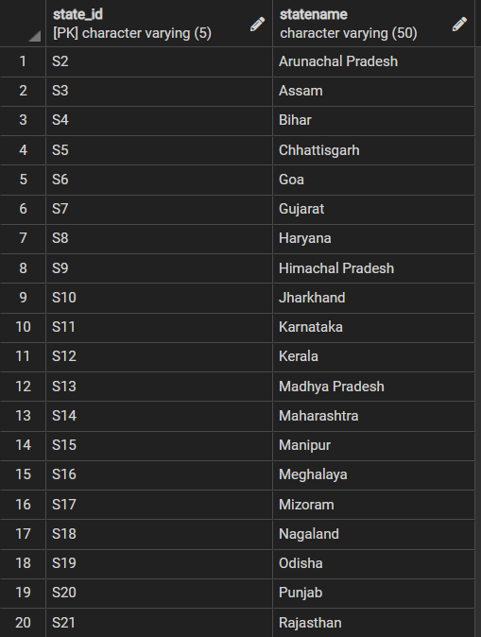 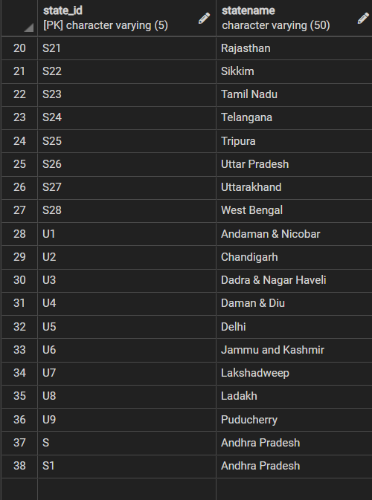

**2) City Table**

INSERT INTO city(city_id,city_name,state_id) VALUES('C101','Amaravati','S1'),('C102','Vishakhapatnam','S1'),('C103','Guntur','S1'),

('C201','Itanagar','S2'),

('C301','Dispur','S3'),

('C401','Patna','S4'),

('C501','Raipur','S5'),

('C601','Panaji','S6'),

('C701','Gandhinagar','S7'),

('C702','Ahmedabad','S7'),

('C703','Surat','S7'),

('C704','Rajkot','S7'),

('C705','Nadiad','S7'),

('C706','Ankleshwar','S7'),

('C707','Vadodara','S7'),

('C801','Chandigarh','S8'),

('C901','Shimla','S9'),

('C1001','Ranchi','S10'),

('C1101','Bengaluru','S11'),

('C1201','Thiruvananthapuram','S12'),

('C1301','Bhopal','S13'),

('C1401','Mumbai','S14'),

('C1501','Imphal','S15'),

('C1601','Shilong','S16'),

('C1701','Aizawl','S17'),

('C1801','Kohima','S18'),

('C1901','Bhubaneshwar','S19'),

('C2001','Chandigarh','S20'),

('C2101','Jaipur','S21'),

('C2201','Gangtok','S22'),

('C2301','Chennai','S23'),

('C2401','Hyderabad','S24'),

('C2501','Agartala','S25'),

('C2601','Lucknow','S26'),

('C2701','Dehradun','S27'),

('C2801','Kolkata','S28'),

('U101','Port Blair','U1'),

('U201','Chandigarh','U2'),

('U301','D&N Haveli','U3'),

('U401','Daman','U4'),

('U501','New Delhi','U5'),

('U601','Srinagar','U6'),

('U701','Kavaratti','U7'),

('U801','Leh','U8'),

('U901','Pondicherry','U9');

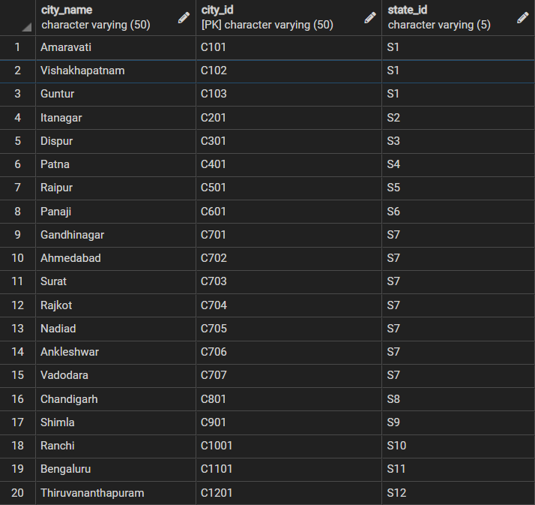 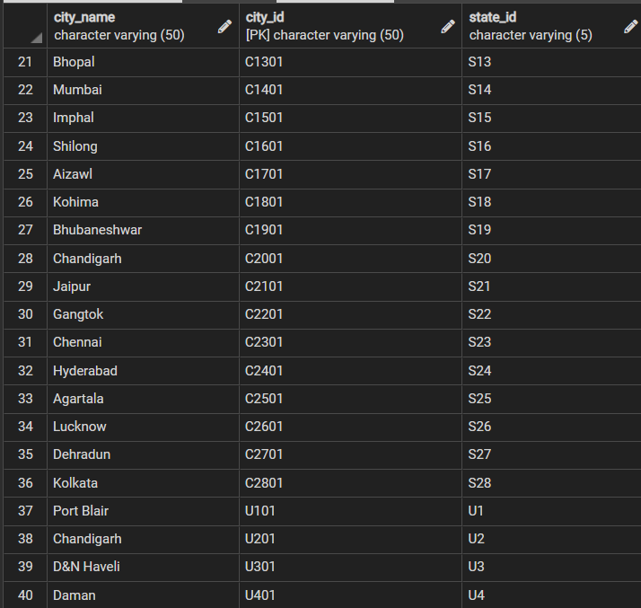

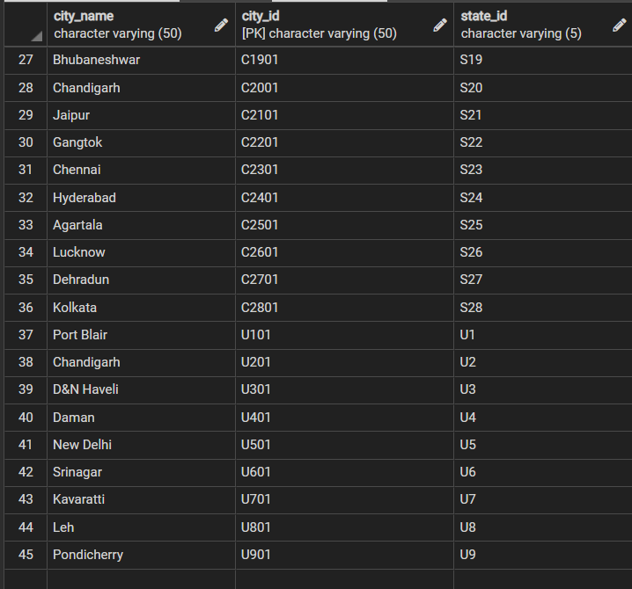

**3)Verification Table**

INSERT INTO verification(verif_id,"Aadhar Card",license) VALUES('V1','1234123412341200','AP0120201234567'),

('V2','1234123412341201','GJ0120191234567'),

('V3','1234123412341202','MH0120181234567'),

('V4','1234123412341203','PN0120171234567'),

('V5','1234123412341204','UP0120201234567'),

('V6','1234123412341205','TN0120211234567'),

('V7','1234123412341206','KN0120161234567'),

('V8','1234123412341207','MP0120001234567'),

('V9','1234123412341208','RJ0120191234567'),

INSERT INTO verification VALUES('V11','1234123412341210',' GJ0120191234576');

INSERT INTO verification VALUES('V12','1234123412341211',' GJ0120191233456');

INSERT INTO verification VALUES('V13','1234123412341212',' GJ0120211234123');

INSERT INTO verification VALUES('V14','1234123412341213',' GJ0120171237340');

INSERT INTO verification VALUES('V15','1234123412341214',' MH0120211234867');

INSERT INTO "verification" values('V16','1234123412341288','AP0120201234568');

INSERT INTO "verification" values('V17','1234123412341204','GJ0120191234561');

INSERT INTO "verification" values('V18','1234123412341205','MH0120181234565');

INSERT INTO "verification" values('V19','1234123412341207','PN0120171234564');

INSERT INTO "verification" values('V20','1234123412341208','UP0120201234568');

INSERT INTO "verification" values('V21','1234123412341209','TN0120211234561');

INSERT INTO "verification" values('V22','1234123412341202','KN0120161234534');

INSERT INTO "verification" values('V23','1234123412341203','MP0120001234556');

INSERT INTO "verification" values('V24','1234123412341204','RJ0120191234598');

INSERT INTO "verification" values('V25','1234123412341205','OR0120141234521');

INSERT INTO "verification" values('V26','1234123412341216',' GJ0120191264579');

INSERT INTO "verification" values('V27','1234123412341217',' GJ0120191293498');

INSERT INTO "verification" values('V28','1234123412341218',' GJ0120211214127');

INSERT INTO "verification" values('V29','1234123412341214',' GJ0120171247342');

INSERT INTO "verification" values('V30','1234123412341211',' MH0120211234861');

INSERT INTO "verification" values('V31','1234123672341288','AP0120261234568');

INSERT INTO "verification" values('V32','1234123892341204','GJ0120181234561');

INSERT INTO "verification" values('V33','1234123232341205','MH0120191234565');

INSERT INTO "verification" values('V34','1234123982341207','PN0120181234564');

INSERT INTO "verification" values('V35','1234123562341208','UP0120211234568');

INSERT INTO "verification" values('V36','1234123122341209','TN0120211234561');

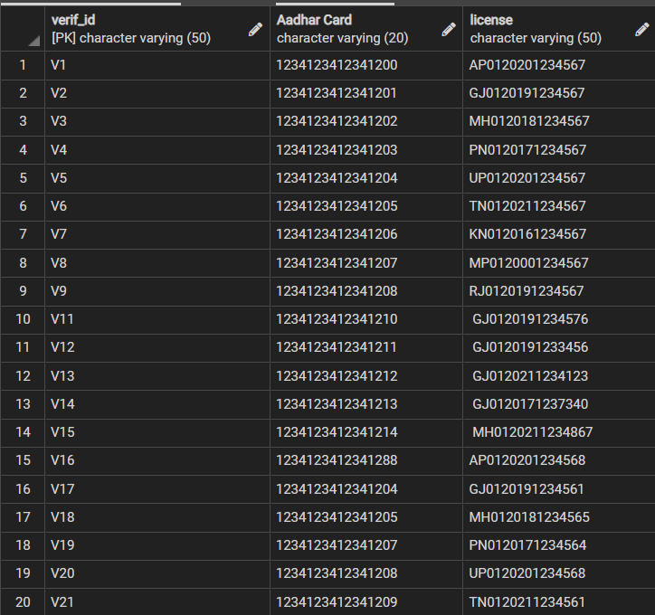 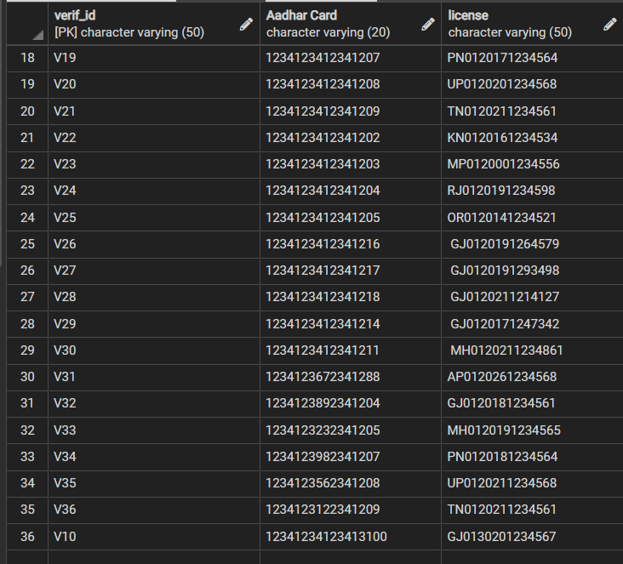

**4)Library Table**

Insert INTO "Library" VALUES('Bank Rd, Beside Bank of, Bajwada, Mandvi, Vadodara', 5000, 'Central Library Mandvi Baroda', 'L101','C707'),

('Station Rd, M.S.U. Compound, M.S.U. University, Maharaja Sayajirao University, Sayajiganj, Vadodara', 17000,'Sir Sayajirao Memorial Trust Library', 'L102','C707'),

('SMES, Gujarat Vidyapith Rd, Sattar Taluka Society, Usmanpura, Ahmedabad', 5500,'Gujarat Vidyapith Library','L103','C702'),

('3046, Gandhi Rd, Old City, Dhalgarwad, Khadia, Ahmedabad',16900,'Dadabhai Navroji Library','L104','C702'),

('SVNIT Surat, Keval Chowk, Surat',20000,'New Central Library SVNIT','L105','C703'),

('6V27+H3X, Near Archana School, Ranujadham Society, Varachha, Surat',2500,'Jhaverchandmeghani Library','L106','C703'),

('7QX6+GXX, Indian Park, Rajkot',4000,'Rajkot Municipal Corporation Library','L107','C704'),

('9, University Road, Jala Ram Nagar, Rajkot',8900,'Shri Ram Reading Room','L108','C704'),

('312, Dr Dadabhai Naoroji Rd, Azad Maidan, Fort, Mumbai, Maharashtra',7000,'J. N. Petit Library','L109','C1401'),

('near Bandra Gymkhana, Mumbai, Maharashtra',11000,'Maharashtra Mitra Mandal Library','L110','C1401'),

('Sai Nagri Society, Shop No A2, Near Nagarwala School, Kalyani Nagar, Bhopal, Ma',16700,'Bookaholic Library','L111','C1301'),

('Kumthekar Road, Sadashiv Peth, near Chitrashala Chowk, Bhopal, Madhya Pradesh',15400,'The Phoenix Library','L112','C1301'),

('Ramakrishna Math Marg, Domalguda, Himayatnagar, Hyderabad, Telangana',13000,'Vivekanand Institute & Library','L113','C2401'),

('8GW9+49R, Sai Ram Nagar, Champapet, Telangana',12300,'City Central Library','L114','C2401'),

('G-9, Blue Cross Chambers, Behind-Safina Plaza, Infantry Rd, Bengaluru, Karnataka',12200,'Eloor Lending Libraries','L115','C1101'),

('IISc Campus, Gulmohar Marg, Devasandra Layout, Bengaluru, Karnataka',12000,'JRD Tata Memorial Library','L116','C1101'),

('Shiv Market, Bhooton Wali Gali, near RWA, Ashok Mohalla, Nangloi Jat, Nangloi, Delhi',11000,'VPS Educational Library','L117','U501'),

('Shiv Market, Bhooton Wali Gali, near RWA, Ashok Mohalla, Nangloi Jat, Nangloi, Delhi',12500,'VPS Educational Library','L118','U501'),

('1/26, 1st Circular St, Jawahar Nagar, Perambur, Chennai, Tamil Nadu',16700,'Branch Library','L119','C2301'),

('54 C, 3rd Street, River View Colony, Block AG, Opp. K3 Police Station, Anna Nagar, Chennai, Tamil Nadu',1800,'Little Love Library','L120','C2301');

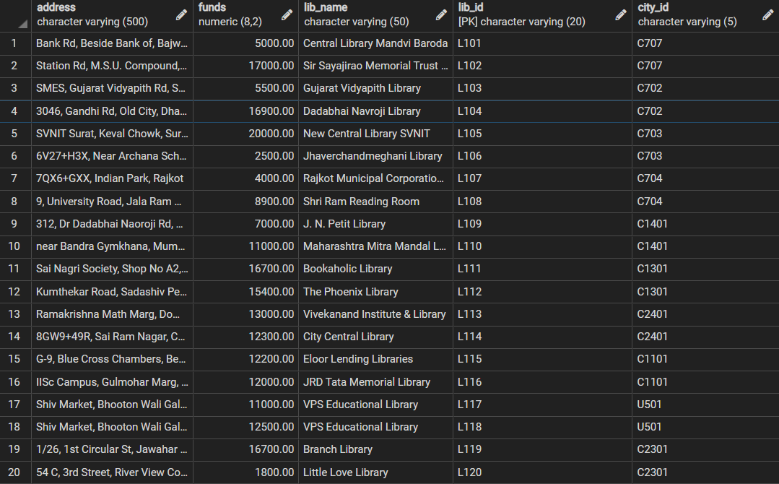

**5) Payment Table**

Insert into Payment values('9392348212@sbi','-','1234 5678 9543 5435','PM00101');

Insert into Payment values('8392348212@icici','-','1234 5678 5623 5435','PM00102');

Insert into Payment values('9392348212@yes','-','4531 5678 9543 5435','PM00103');

Insert into Payment values('-','-','1234 5034 5932 5435','PM00104');

Insert into Payment values('-','-','7565 5678 9543 8664','PM00105');

Insert into Payment values('9912372729@icici','-','1234 5678 9543 8064','PM00106');

Insert into Payment values('9912345678@hdfc','-','6355 5678 9543 5435','PM00107');

Insert into Payment values('9392348212@kotak','-','8644 5678 9543 5435','PM00108');

Insert into Payment values('9392897045@sbi','-','3453 5678 9543 5435','PM00109');

Insert into Payment values('9456734523@bob','-','1753 5678 9543 5435','PM00110');

Insert into Payment values('8877663456@bob','-','1234 5678 9543 5435','PM00111');

Insert into Payment values('9999996660@sbi','-','5333 5678 3242 5435','PM00112');

Insert into Payment values('9397689050@icici','-','9021 4534 6435 2231','PM00113');

Insert into Payment values('9399877896@sbi','-','9021 4534 6435 3742','PM00114');

Insert into Payment values('4323424216@hdfc','-','9021 6435 2231 3424','PM00115');

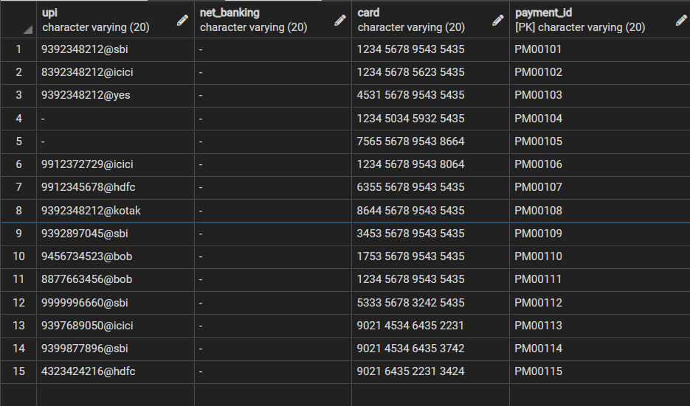

**6)User Table**

Insert into "User" values('Dinky','Lakhani',9392348212,'A101 ,Platinium Towers , University Road , Rajkot - 360001','fjjdsnkd','24-06-2001','gyeoroo24@gmail.com','L107','V2','PM101');

Insert into "User" values('Sharvari','Gadkari',8392348212,'"Heaven" ,Nityaprabaha Street ,Delhi','kdflgmdfk','14-02-2001','sharvarigad14@gmail.com','L117','V1','PM00102');

Insert into "User" values('Nirupama','Das',9392348212,'"Paradise Villa" , Block D ,Dr. Chopra Road,New Delhi','kgmfgkwq','04-07-2000','nirupamadas123@gmail.com','L118','V3','PM00103');

Insert into "User" values('Suresh','Agarwal',9392322222,'Sai Nagri Society, Shop No A2, Near Nagarwala School, Kalyani Nagar , Bhopal','ghkkfskfd','24-12-1999','sureshagarwal54@yahoo.com','L111','V5','PM00104');

Insert into "User" values('Nitya','Chaudhary',9392313121,'Kumthekar Road, Sadashiv Peth, near Chitrashala Chowk, Bhopal , M.P.','2392&203kfsk','02-01-1993','nityachaudhary65@gmail.com','L112','V4','PM00105');

Insert into "User" values('Aastha','Modi',9912372729,'701,Shanti Heights,Opposite SNK School, , University Road , Rajkot','4349jfnjf*jfs','02-02-2001','aasthamodi02@gmail.com','L107','V7','PM00106');

Insert into "User" values('Yami','Gautam',9912345678,'A101 , Jalaram Tower ,Navrangpura Main Road , Ahmedabad','fkfklq139da','14-03-2010','yamigautam1410@hotmail.com','L104','V6','PM00107');

Insert into "User" values('Varshita','Goti',9392897045,'C301 ,Varday Residency,L.P. Savani Road, Surat','hllte032mf','15-09-2000','varshi15@gmail.com','L105','V8','PM00108');

Insert into "User" values('Gurvinder','Singh',9456734523,'S123 ,Silver Plaaza,Gotri Road, Vadodara','fknkf0023d','10-06-2001','gurvinders1221@gmail.com','L101','V9','PM00109');

Insert into "User" values('Yasin','Sheikh',8877663456,'"Shanti Niketan",M.S University Road,Saiyajignaj, Vadodara','rktekt3995','13-04-1996','yasinsheikh786@gmail.com','L102','V10','PM00110');

Insert into "User" values('Isha','Keshariya',9999996660,'IISc Campus, Gulmohar Marg, Devasandra Layout, Bengaluru, Karnataka 560012','749fjdfnq&^&9','04-01-2001','ishakeshariya0401@gmail.com','L116','V12','PM00111');

Insert into "User" values('Shobita','Dhar',9397689050,'"501 Veena Apartments"Jayanagar 3rd Block, South End Circle, Opposite Vivek Showroom, Bengaluru, Karnataka 560011','rwkre^&T*3','12-12-1997','shobitadhar@yahoo.com','L115','V11','PM00112');

Insert into "User" values('Ranveer','Khurrana',9399877896,' "Aiyappa" ,Beside Goverment Maternity Hospital , Pantheon Road , Chennai','Lkgdg^%$^dsdf','18-02-1998','ranveekhana1802@gmail.com','L119','V13','PM00113');

Insert into "User" values('Udayveer','Jaisingh',4323424216,'Sukh Sadan, Laxman Nagar, Champapet, Telangana','oqwoeqa&^^','03-05-1987','udaybhan0305@gmail.com','L114','V15','PM00114');

Insert into "User" values('Siya','Rathod',9392344455,'C504 , 13th Street, River View Colony, Block AG, Opp. K3 Police Station, Anna Nagar , Chennai , Tamil Nadu','SDAKkds**&12','02-04-1992','siyarathod0204@gmail.com','L119','V14','PM00115');

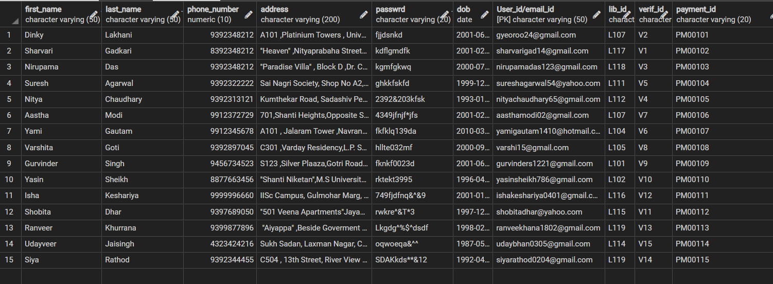

**7)Membership Table**

Insert into membership values(1000,'UPI','PM00101');

Insert into membership values(1000,'UPI','PM00102');

Insert into membership values(750,'UPI','PM00103');

Insert into membership values(3000,'Debit Card','PM00104');

Insert into membership values(1000,'Rupay Card','PM00105');

Insert into membership values(1000,'UPI','PM00106');

Insert into membership values(400,'UPI','PM00107');

Insert into membership values(1000,'UPI','PM00108');

Insert into membership values(750,'Debit Card','PM00109');

Insert into membership values(1000,'UPI','PM00110');

Insert into membership values(400,'Rupay Card','PM00111');

Insert into membership values(750,'UPI','PM00112');

Insert into membership values(1000,'UPI','PM00113');

Insert into membership values(1000,'Debit Card','PM00114');

Insert into membership values(3000,'Debit Card','PM00115');

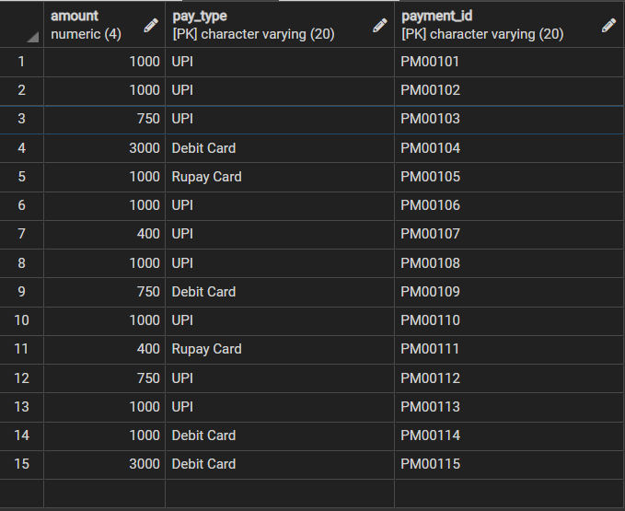

**8)Feedback Table**

Insert into feedback values('Dinky','Amazing collection of books !!! The library gives a proper study vibe. The staff is very cooperative',4.0,'gyeoroo24@gmail.com');

Insert into feedback(review,rating,"User_id/email_id","Lib_id") values('Can Improve their taste in Book Collection.Many of the popular books and best-sellers are not even displayed or mentioned for e.g. Sudha Murty',2.5,'ranveekhana1802@gmail.com','L101');

Insert into feedback values('Random Chikibum','Good Infrastructure of the Library',4.0,'siyarathod0204@gmail.com','L102');

Insert into feedback(review,rating,"User_id/email_id","Lib_id") values('Can Increase the Scriptures and Historical/Religious Books for the Elderly',3.0,'sureshagarwal54@yahoo.com','L101');

Insert into feedback values('Yami','This Library is a bit Suffocating. Can improve the infrasturcture and greenary around',1.5,'yamigautam1410@hotmail.com','L111');

Insert into feedback(review,rating,"User_id/email_id","Lib_id") values('Has Kickass Books and magazines. Must Visist !!!',5.0,'yasinsheikh786@gmail.com','L112');  
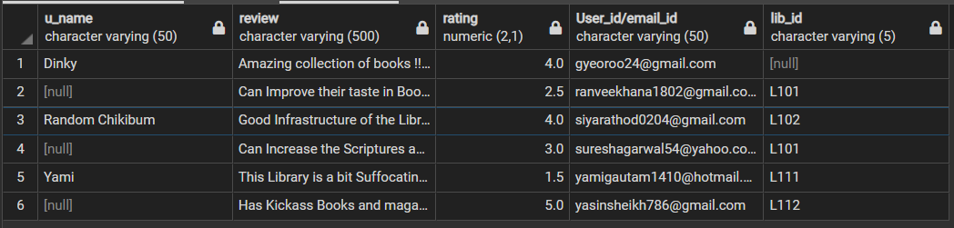

**9) Book Table**

INSERT INTO book(isbn,b_name,genre,edition,type,lib_id,ratings,"Language") VALUES(9788129104595,'Five Point Someone','Fiction',1,'Paperback','L101',3.4,'English'),

(9780143103295,'Mahashweta','Fiction',1,'Paperback','L101',4.1,'English'),

(9788186172810,'Dollar Bahu','Domestic Fiction',1,'Paperback','L102',3.7,'English'),

(9780143422259,'The Mother I Never Knew','Fiction',1,'Paperback','L102',3.7,'English'),

(9780143444343,'Here , There And Everywhere','Autobiography',1,'Paperback','L103',4.3,'English'),

(9788184004328,'Ex','Fiction',1,'Paperback','L103',3.9,'English'),

(9783785756003,'Origins','Mystery thriller Fiction',1,'Paperback','L104',4.2,'English'),

(9780142414934,'Paper Towns','Fiction',1,'Paperback','L104',4.0,'English'),

(9780747507420,'Word Power Made Easy','Self-Help',1,'Hardcover','L105',4.4,'English'),

(9789381841181,'Till the Last Breath','Romantic Fantasy',1,'Hardcover','L106',4.0,'English'),

(9781565115187,'The Story of my Experiments with Truth','Autobiography',1,'Paperback','L106',4.1,'English'),

(9780141345659,'The Fault in Our Stars','Young Adult Fiction',1,'Paperback','L105',4.2,'English'),

(9783954713851,'Predictably Irrational','Non-fition',1,'Paperback','L107',4.1,'English'),

(9783442315536,'12 Rules for Life','Self-Help',1,'Hardcover','L107',3.9,'English'),

(9783863524586,'Moby Dick','Adventure Fiction',1,'Hardcover','L108',3.5,'English'),

(9788809810570,'Little Women','Children Literature',1,'Hardcover','L108',4.1,'English'),

(9781101524275,'Drive: The Surprising Truth About What Motivates Us','Self-Help',1,'Hardcover','L109',3.9,'English'),

(9780716726180,'The Social Animal','Non-Fiction',12,'Paperback','L109',3.9,'English'),

(9780141182704,'Animal Farm','Political Satire',1,'Paperback','L110',4.0,'English'),

(9780143130727,'Ikigai','Self-Help',1,'Paperback','L110',3.7,'English'),

(9780007617012,'The God of Small Things','Psychological Fiction',1,'Paperback','L111',3.9,'English'),

(9780143441984,'The Best Couple Ever ','Fiction',1,'Paperback','L111',4.5,'English'),

(9780143442691,'Half Torn Hearts','Fiction',1,'Paperback','L112',4.5,'English'),

(9788184007906,'Black Suits You','Fiction',1,'Paperback','L113',4.4,'English'),

(9780143427490,'Forever is a Lie','Fiction',1,'Hardcover','L113',4.5,'English'),

(9780143427506,'Forever is True','Fiction',2,'Hardcover','L114',4.4,'English'),

(9781612680194,'Rich Dad Poor Dad','Finance',1,'Hardcover','L114',4.6,'English'),

(9789387944893,'The 5 AM Club','Non-Fiction',1,'Hardcover','L115',4.5,'English'),

(9780091929114,'The 4-Hour Work Week','Reference',1,'Hardcover','L115',4.4,'English'),

(9780753555194,'Zero to One','Economics',1,'Hardcover','L116',4.2,'English'),

(9780143109099,'Your One Word','Self-Help',1,'Hardcover','L116',4.8,'English'),

(9789353336899,'How to Become Rich','Personal Transformation',1,'Paperback','L117',4.3,'English'),

(9788129137708,'My Gita','Historical Fiction',1,'Hardcover','L117',4.4,'English'),

(9789385152146,'Ram - Scion of Ikshvaku','Historical Fiction',1,'Paperback','L118',4.4,'English'),

(9780143449522,'Whisper to Me Your Lies ','Fiction',1,'Hardcover','L119',4.1,'English'),

(9781637455081,'Wandering Wheels','Travel Writing',1,'Hardcover','L118',4.9,'English'),

(9789380741116,'The Treasured Thief: A Graphic Novel','Comics',1,'Paperback','L119',4.0,'English'),

(9781449474195,'Adulthood Is a Myth','Humour',1,'Comics','L120',4.7,'English'),

(9781408855652,'Harry Potter and the Philosophers Stone','Contemporary Fiction',2011,'Paperback','L120',4.7,'English'),

(9788129144973,'The Perfect Murder','Crime Fiction',1,'Paperback','L101',3.9,'English'),

(9788129135094,'A Fistful of Earth and Other Stories','Short stories',1,'Paperback','L102',4.4,'English'),

(9780241370148,'This is Marketing','Creativity',1,'Paperback','L103',4.5,'English'),

(9781861976109,'The 22 Immutable Laws Of Marketing','Analysis & Strategy',1,'Paperback','L110',4.6,'English'),

(9789390166268,'The Psychology of Money','Analysis & Strategy',1,'Paperback','L117',4.2,'English');

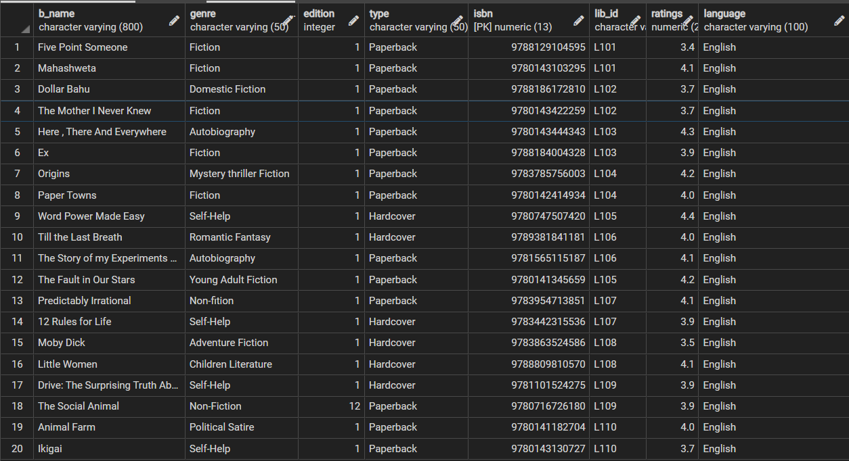 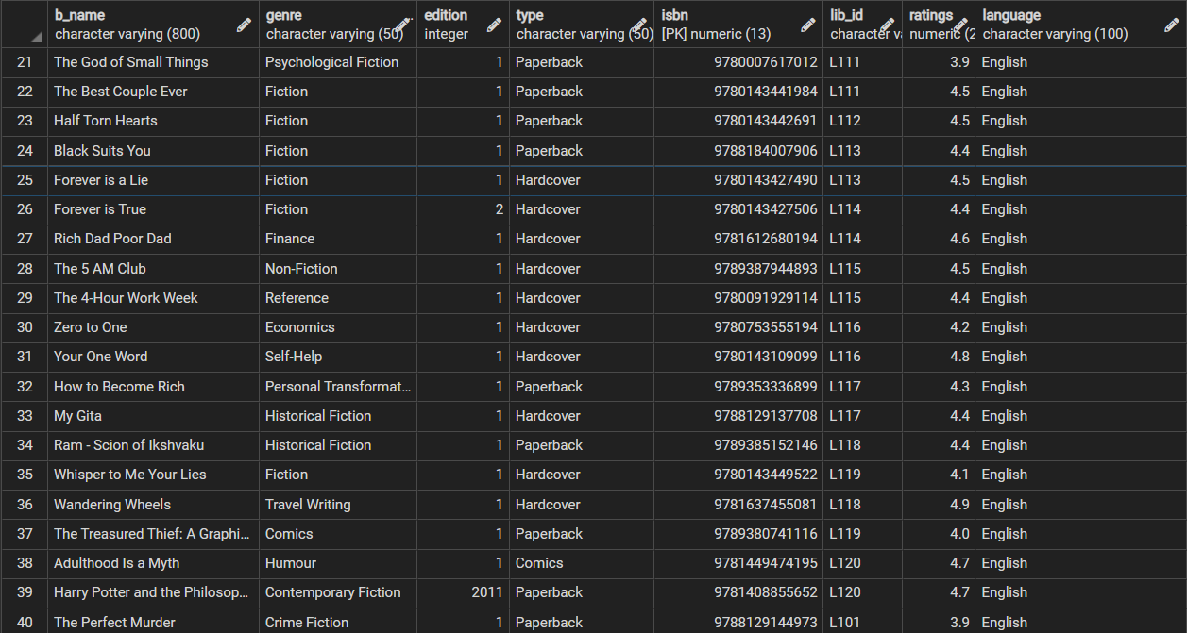

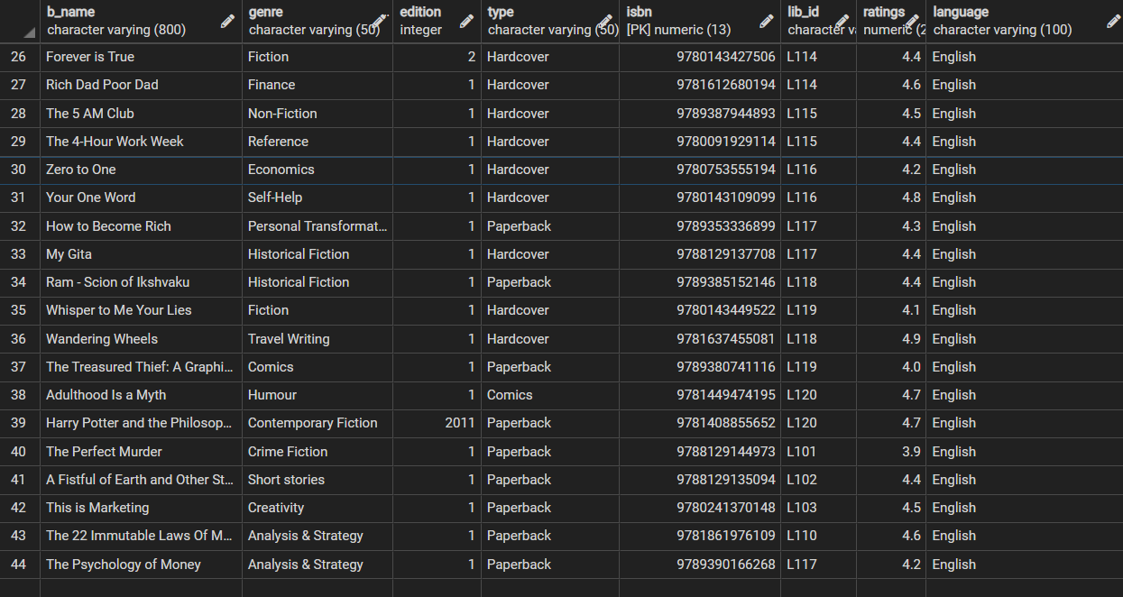

**10)Author Table**

INSERT INTO author(author_id,author_name,gender,isbn) VALUES('A1','Chetan Bhagat','M',9788129104595),

('A2','Sudha Murty','F',9780143103295),

('A3','Dan Brown','M',9783785756003),

('A4','Sudha Murty','F',9788186172810),

('A5','Sudha Murty','F',9780143422259),

('A6','Sudha Murty','F',9780143444343),

('A7','Novoneel Chakraborty','M',9788184004328),

('A8','John Green','M',9780142414934),

('A9','Norman Lewis','M',9780747507420),

('A10','Durjoy Dutta','M',9789381841181),

('A11','Mahatma Gandhi','M',9781565115187),

('A12','John Green','M',9780141345659),

('A13','Dan Areily','M',9783954713851),

('A14','Jordan Peterson','M',9783442315536),

('A15','Herman Melville','M',9783863524586),

('A16','Louisa May Alcott','F',9788809810570),

('A17','Daneil H. Pink','M',9781101524275),

('A18','Elliot Aronson','M',9780716726180),

('A19','George Orwell','M',9780141182704),

('A20','Hector Garcia','M',9780143130727),

('A21','Francesc Miralles','M',9780143130727),

('A22','Novoneel Chakraborty','M',9780143441984),

('A23','Novoneel Chakraborty','M',9780143442691),

('A24','Novoneel Chakraborty','M',9788184007906),

('A25','Novoneel Chakraborty','M',9780143427490),

('A26','Novoneel Chakraborty','M',9780143427506),

('A27','Robert T. Kiyosaki','M',9781612680194),

('A28','Robin Sharma','M',9789387944893),

('A29','Timothy Ferriss','M',9780091929114),

('A30','Blake Masters','M',9780753555194),

('A31','Peter Thiel','M',9780753555194),

('A32','Evan Carmicheal','M',9780143109099),

('A33','Devdutt Pattnaik','M',9789353336899),

('A34','Devdutt Pattnaik','M',9788129137708),

('A35','Amish Tripathi','M',9789385152146),

('A36','Novoneel Chakraborty','M',9780143449522),

('A37','Sushant Kaushik','M',9781637455081),

('A38','Ryan Foley','M',9789380741116),

('A39','Sarah Anderson','F',9781449474195),

('A40','J.K. Rowling','F',9781408855652),

('A41','Ruskin Bond','M',9788129144973),

('A42','Siddhartha Gigoo','M',9788129135094),

('A43','Seth Godin','M',9780241370148),

('A44','Joao Bosco Medeires','M',9780241370148),

('A45','Al Ries','M',9781861976109),

('A46','Morgan Housel','M',9789390166268);

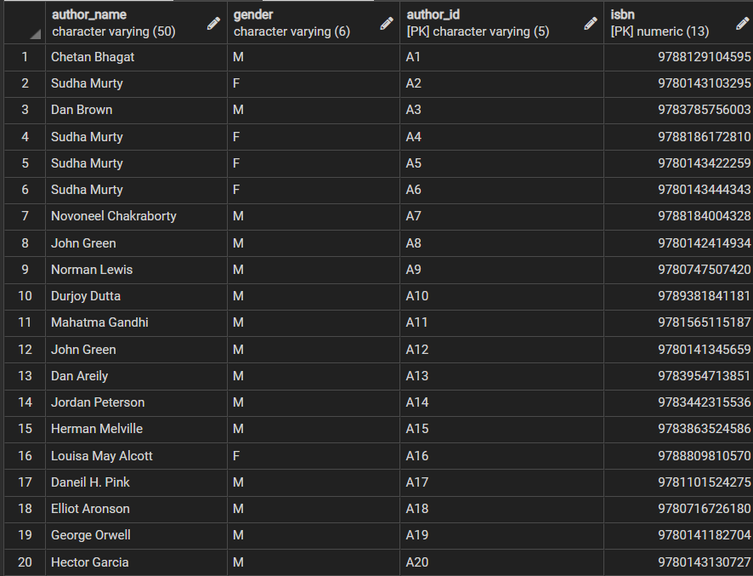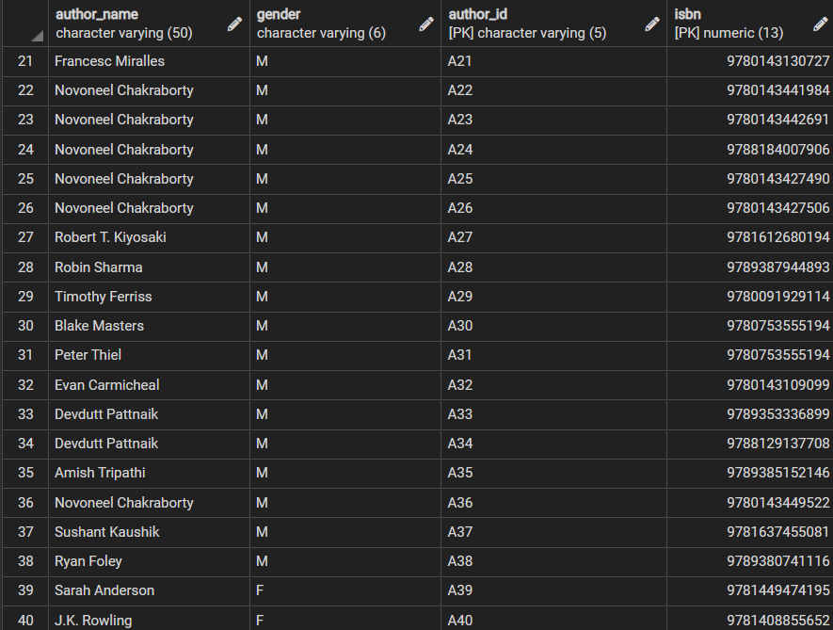

**11) Publisher table**

INSERT into publisher(pub_id,pname,yop,isbn) VALUES('P1','Rupa Publications','2004-10-13',9788129104595),

('P2','Penguin Random House','2000-09-12',9780143103295),

('P3','Penguin Random House','2003-08-11',9788186172810),

('P4','Penguin Random House','2014-07-10',9780143422259),

('P5','Penguin Random House','2018-06-09',9780143444343),

('P6','Penguin Random House','2016-05-08',9788184004328),

('P7','Double Day','2017-04-07',9783785756003),

('P8','Dutton Books','2008-03-06',9780142414934),

('P9','Penguin Books','1949-02-05',9780747507420),

('P10','Penguin Random House','2012-01-04',9789381841181),

('P11','Jaico Publishing House','2019-02-03',9781565115187),

('P12','Dutton Books','2012-03-02',9780141345659),

('P13','Halper Collins','2008-04-01',9783954713851),

('P14','Random House Canada Penguin Allen Lane','2018-05-30',9783442315536),

('P15','Richard Bentley (England) Harper & Brothers (US)','1851-06-29',9783863524586),

('P16','Robert Brothers','1868-07-28',9788809810570),

('P17','RiverHead Books','2009-08-27',9781101524275),

('P18','Random House','1972-09-26',9780716726180),

('P19','Simon & Schuster','1945-10-25',9780141182704),

('P20','penguin random house','2016-11-24',9780143130727),

('P21','Penguin Metro Reads','2018-12-23',9780143441984),

('P22','Penguin','2019-11-22',9780143442691),

('P23','penguin random house','2016-10-21',9788184007906),

('P24','penguin random house','2017-09-20',9780143427490),

('P26','penguin random house','2017-08-19',9780143427506),

('P27','Plata Publishing','2017-07-18',9781612680194),

('P28','Jaico Publishing House','2018-06-17',9789387944893),

('P29','RHUK','2011-05-16',9780091929114),

('P30','Random House','2014-04-15',9780753555194),

('P31','Penguin','2017-03-14',9780143109099),

('P32','Rupa Publications','2019-02-13',9789353336899),

('P33','Rupa Publications','2015-01-12',9788129137708),

('P34','Westland Limited','2015-02-11',9789385152146),

('P35','Penguin Metro Reads','2021-03-10',9780143449522),

('P36','Notion Press','2021-04-09',9781637455081),

('P37','Campfire','2012-05-08',9789380741116),

('P38','Andrews McMeel Publishing','2016-06-07',9781449474195),

('P39','Bloomsbury Childrens Books','2014-07-06',9781408855652),

('P40','Rupa Publications India','2016-08-05',9788129144973),

('P41','Rupa Publications India','2015-09-04',9788129135094),

('P42','Portfolio Penguin','2018-10-03',9780241370148),

('P43','Profile Books Ltd','1994-11-02',9781861976109),

('P44','Jaico Publishing House','2020-12-01',9789390166268);

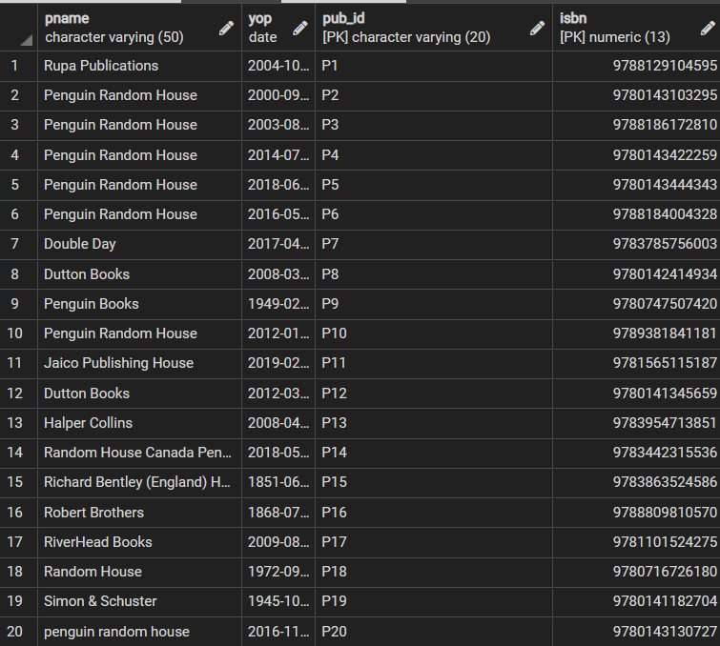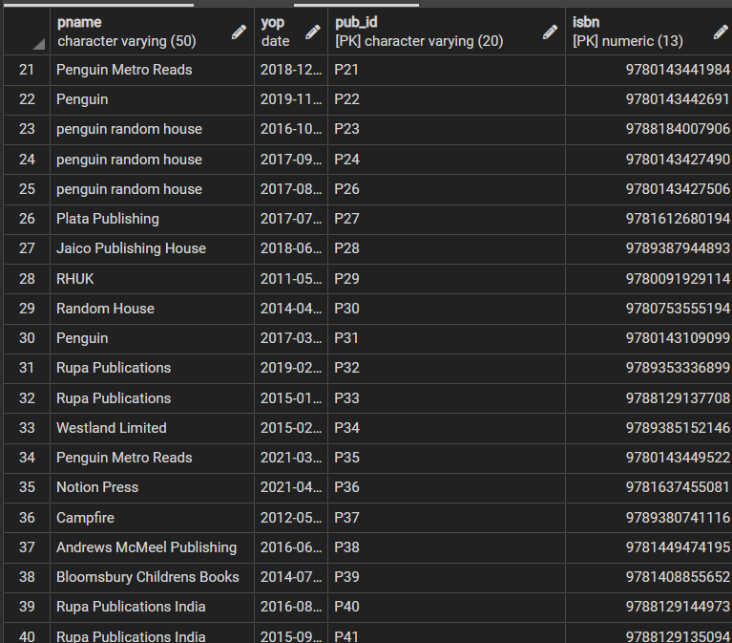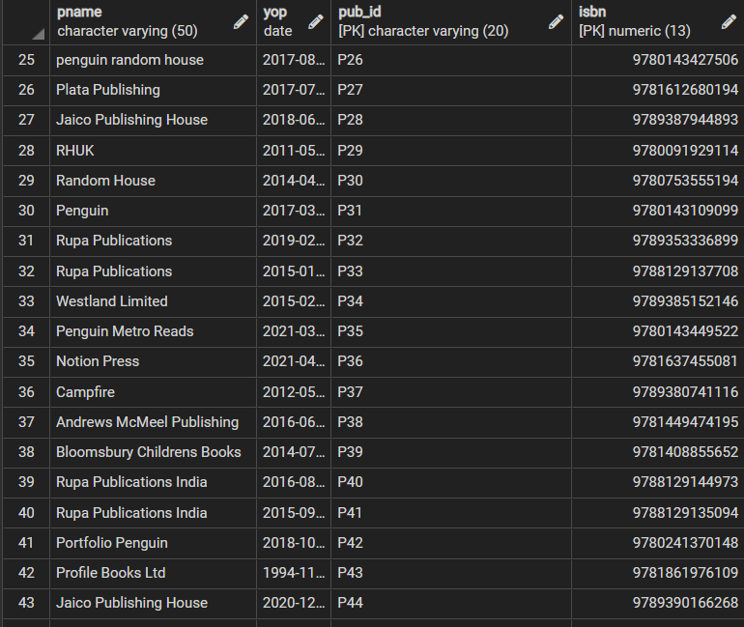

**12)Return/Issue Table**

Insert into "Return/Issue"("Issue/Renew_date",a_ret_date,"User_id/email_id",isbn) values('17-09-2021','01-10-2021','gyeoroo24@gmail.com',9783954713851);

Insert into "Return/Issue"(hold_date,"User_id/email_id",isbn) values('18-09-2021','gyeoroo24@gmail.com',9783442315536);

Insert into "Return/Issue"("Issue/Renew_date",a_ret_date,"User_id/email_id",isbn) values('14-09-2021','28-09-2021','sharvarigad14@gmail.com',9788129137708);

Insert into "Return/Issue"("Issue/Renew_date",a_ret_date,"User_id/email_id",isbn) values('10-09-2021','24-09-2021','yasinsheikh786@gmail.com',9780143422259);

Insert into "Return/Issue"(hold_date,"User_id/email_id",isbn) values('10-09-2021','yasinsheikh786@gmail.com',9788186172810);

Insert into "Return/Issue"("Issue/Renew_date",user_ret_date,a_ret_date,"User_id/email_id",isbn) values('10-09-2019','24-09-2021','26-09-2021','udaybhan0305@gmail.com',9780143427506);

Insert into "Return/Issue"(hold_date,"User_id/email_id",isbn) values('26-09-2019','udaybhan0305@gmail.com',9781612680194);

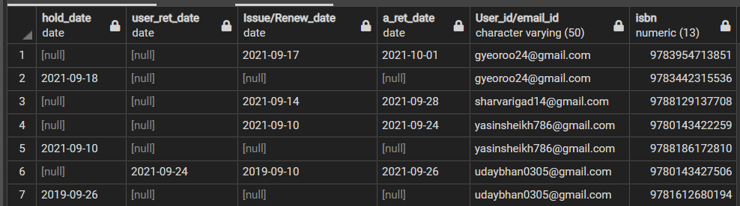

**13)Employee Table**

Insert INTO Employee values('librarian','Yash','Parmar',25000,'E101','L101');

Insert INTO Employee values('staff','Binal','Modi',30000,'E102','L102');

Insert INTO Employee values('watchman','Ketan','Khare',21000,'E103','L110');

Insert INTO Employee values('librarian','Kamlesh','Mehta',23000,'E104','L111');

Insert INTO Employee values('librarian','Darshan','Mali',26000,'E105','L112');

Insert INTO Employee values('watchman','Darsh','Patel',26000,'E106','L113');

Insert INTO Employee values('staff','Margi','Chaudhry',26000,'E107','L114');

Insert INTO Employee values('watchman','Kashish','Panvala',26000,'E108','L115');

Insert INTO Employee values('librarian','Hiya','Bidivala',26000,'E109','L116');

Insert INTO Employee values('librarian','Priyanshi','Sarvan',26000,'E110','L117');

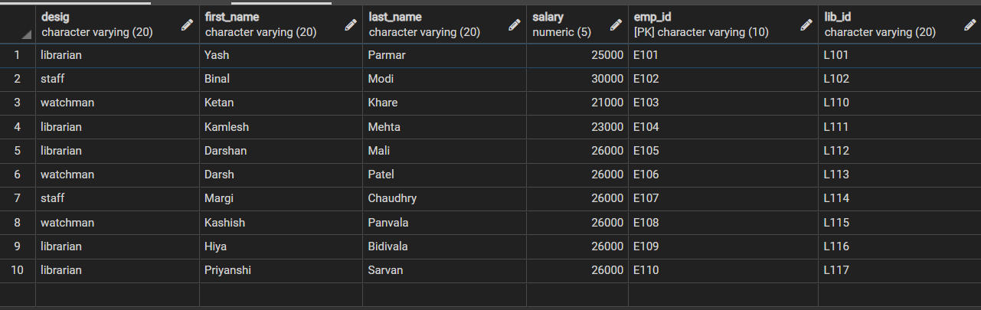

**14)Admin Table**

Insert INTO admin values('kenilmodi10@gmail.com','L101','V16','Kenil','Modi',1234567892,'kenil@123','country Admin', '10/01/1998');

Insert INTO admin values('vrajmodi11@gmail.com','L101','V17','Vraj','Modi',3425678297,'vraj@123','city Admin', '11/03/1998');

Insert INTO admin values('aasthamodi22@gmail.com','L102','V18','Aastha','Modi',8903420091,'aastha@123','state Admin','02/02/1996');

Insert INTO admin values('ketulmodi7977@gmail.com','L103','V19','Ketul','Modi',9034330056,'ketul@123','city Admin','07/09/1987');

Insert INTO admin values('chelsipatel22@gmail.com','L104','V20','Chelsi','Patel','6782380167','chelsi@123','city Admin','24/06/1988');

Insert INTO admin values('gurvisingh45@yahoo.com','L105','V21','Gurvindr','Singh',7830088453,'gurvi@123','State Admin','05/02/1999');

Insert INTO admin values('nileshmodi34@yahoo.com','L106','V22','Nilesh','Modi',6549920821,'nilesh@123','city Admin','29/03/1979');

Insert INTO admin values('riya34parmar@gmail.com','L107','V23','Riya','Parmar',6598055275,'riya@123','city Admin','20/09/1992');

Insert INTO admin values('rishimehta1101@gmail.com','L108','V24','Rishi','Mehta',604581442,'rishi@123','state Admin','11/01/1990');

Insert INTO admin values('vinit2903@gmail.com','L109','V25','Vinit','Patel',5043175001,'vinit@123','city Admin','29/03/1989');

Insert INTO admin values('sudhirpatel12@gmail.com','L110','V26','Sudhir','Patel',7830180399,'sudhir@123','city Admin','13/10/1989');

Insert INTO admin values('shivani786hal@gmail.com','L111','V27','Shivani','Haldariya',9925143657,'shivani@123','city Admin','27/01/1984');

Insert INTO admin values('riya89modi@yahoo.com','L112','V28','Riya','Modi',9265320156,'riya@891','city Admin','24/08/1996');

Insert INTO admin values('ranjanguvaliwala56@yahoo.com','L113','V29','Ranjan','Guvaliwala',7820065964,'ranjan@123','city Admin','01/06/1987');

Insert INTO admin values('deepakguvaliwala@gmail.com','L114','V30','Deepak','Guvali',8934992316,'deepak@123','state Admin','07/06/1988');

Insert INTO admin values('mihir123gol@gmail.com','L116','V32','Mihir','Golvala',1965332109,'mihir@123','city Admin','14/02/1997');

Insert INTO admin values('janvi98@gmail.com','L117','V33','janvi','vyas',9873460102,'janvi@123','city Admin','07/09/1995');

Insert INTO admin values('saurabh56@gmail.com','L118','V34','Saurabh','Dave',9813455442,'saurabh@123','city Admin','05/05/1986');

Insert INTO admin values('archana12@gmail.com','L119','V35','Archana','Lakdavala',7657701032,'archana@123','city Admin','02/06/1995');

Insert INTO admin values('mohitparmar34@gmail.com','L120','V36','Mohit','Parmar',9005614229,'mohit@123','city Admin','06/04/1996');

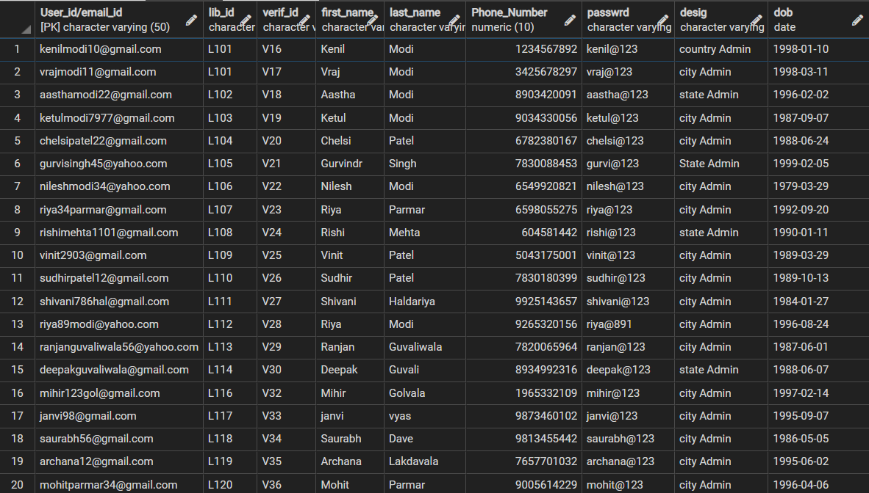

**15) Merits/Demerits Table**

INSERT INTO "Merits/demerits" values(4.5,'archana12@gmail.com','ranveekhana1802@gmail.com'),

(3.0,'saurabh56@gmail.com','nirupamadas123@gmail.com'),

(3.1,'mihir123gol@gmail.com','ishakeshariya0401@gmail.com'),

(3.2,'deepakguvaliwala@gmail.com','udaybhan0305@gmail.com'),

(2.2,'chelsipatel22@gmail.com','yamigautam1410@hotmail.com'),

(3.5,'riya34parmar@gmail.com','gyeoroo24@gmail.com'),

(3.0,'janvi98@gmail.com','sharvarigad14@gmail.com'),

(3.2,'nileshmodi34@yahoo.com','nirupamadas123@gmail.com'),

(3.1,'shivani786hal@gmail.com','sureshagarwal54@yahoo.com'),

(3.9,'gurvisingh45@yahoo.com','varshi15@gmail.com'),

(3.4,'vrajmodi11@gmail.com','gurvinders1221@gmail.com'),

(4.5,'archana12@gmail.com','siyarathod0204@gmail.com'),

(1.5,'aasthamodi22@gmail.com','yasinsheikh786@gmail.com'),

(3.3,'riya89modi@yahoo.com','nityachaudhary65@gmail.com');

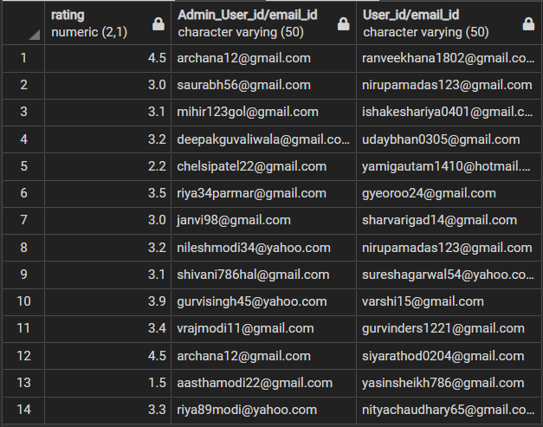

**16)Quantity Table**

Insert into "Quantity" values(9788129104595,'L101',5),

(9780143103295,'L101',7),

(9788186172810,'L102',9),

(9780143422259,'L102',11),

(9780143444343,'L103',3),

(9788184004328,'L103',4),

(9783785756003,'L104',2),

(9780142414934,'L104',1),

(9780747507420,'L105',10),

(9789381841181,'L106',3),

(9781565115187,'L106',5),

(9780141345659,'L105',6),

(9783954713851,'L107',8),

(9783442315536,'L107',9),

(9783863524586,'L108',12),

(9788809810570,'L108',13),

(9781101524275,'L109',11),

(9780716726180,'L109',15),

(9780141182704,'L110',20),

(9780143130727,'L110',10),

(9780007617012,'L111',2),

(9780143441984,'L111',3),

(9780143442691,'L112',4),

(9788184007906,'L113',6),

(9780143427490,'L113',7),

(9780143427506,'L114',8),

(9781612680194,'L114',8),

(9789387944893,'L115',1),

(9780091929114,'L115',2),

(9780753555194,'L116',2),

(9780143109099,'L116',5),

(9789353336899,'L117',5),

(9788129137708,'L117',11),

(9789385152146,'L118',12),

(9780143449522,'L119',15),

(9781637455081,'L118',10),

(9789380741116,'L119',5),

(9781449474195,'L120',6),

(9781408855652,'L120',6),

(9788129144973,'L101',7),

(9788129135094,'L102',7),

(9780241370148,'L103',8),

(9781861976109,'L110',1),

(9789390166268,'L117',2);

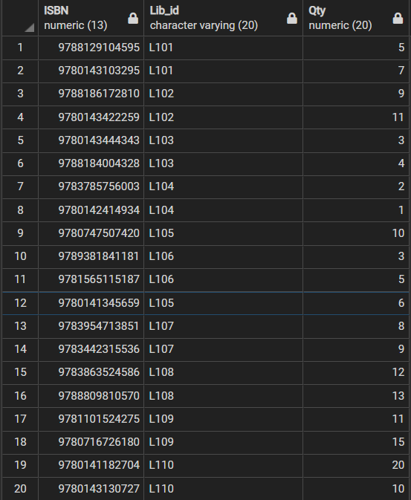 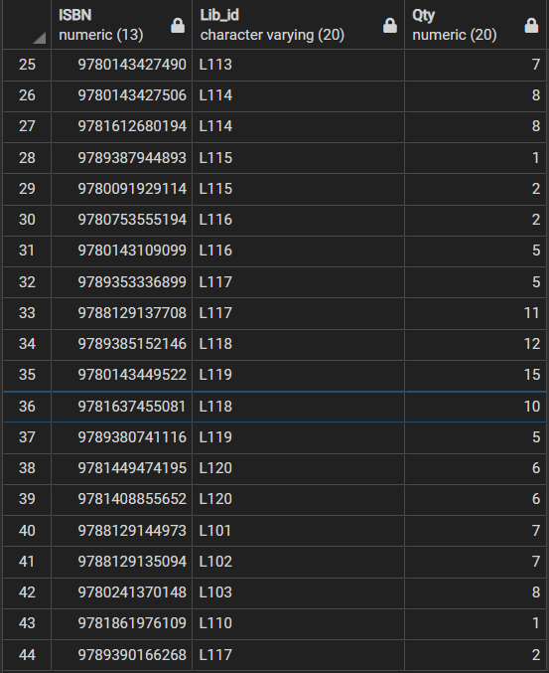

-----------------------------------------------------------------------------------------

**Basic Queries**

**1) Select isbn,yop,pname from publisher order by yop;**

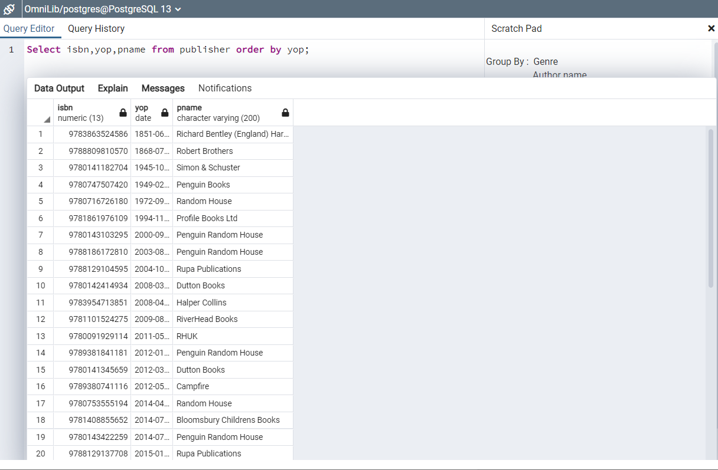

**2) Select b_name,edition,genre,"Language",ratings from book order by ratings desc;**

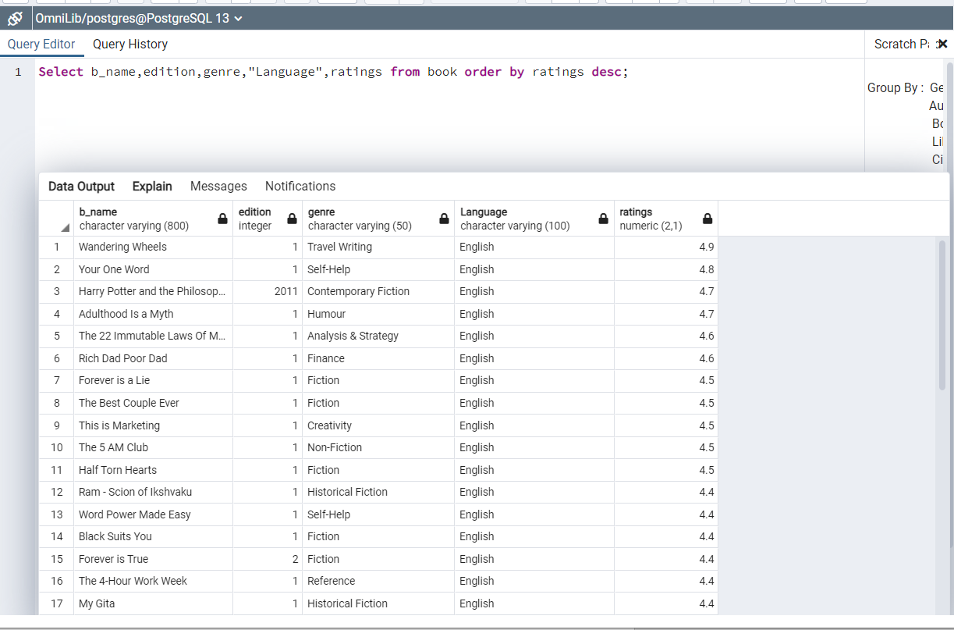

**3) Select genre,count(isbn) from book group by genre;**

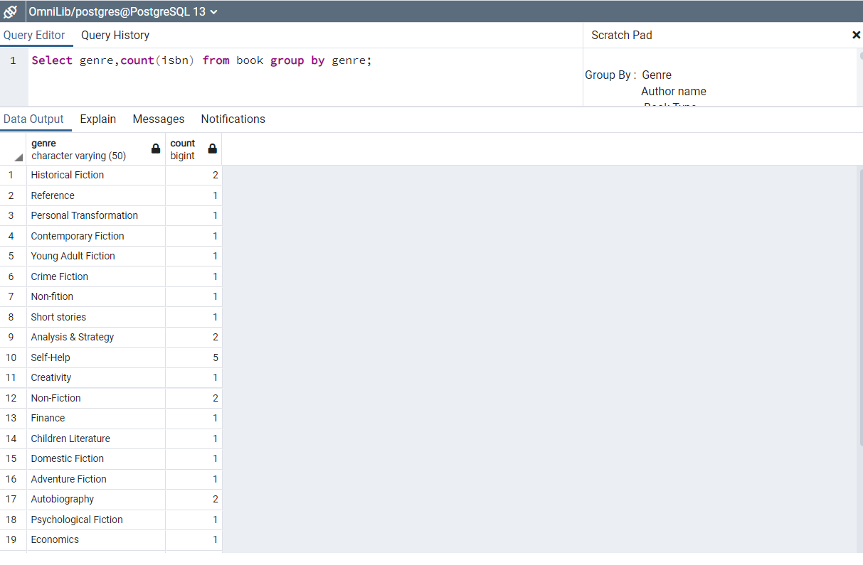

**4) select b_name,edition,genre,isbn,"Language",lib_id from book where lib_id in ('L101','L118','L110');**

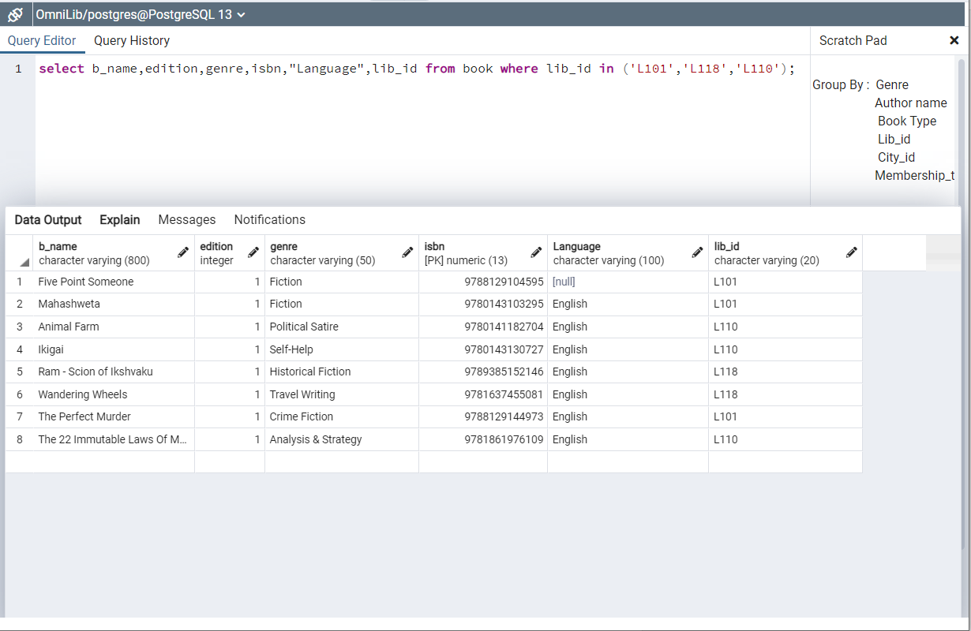

**5)Select first_name,last_name,phone_number,dob,"User_id/email_id",lib_id from "User" where dob between '01-01-1995' AND '31-12-2005';**

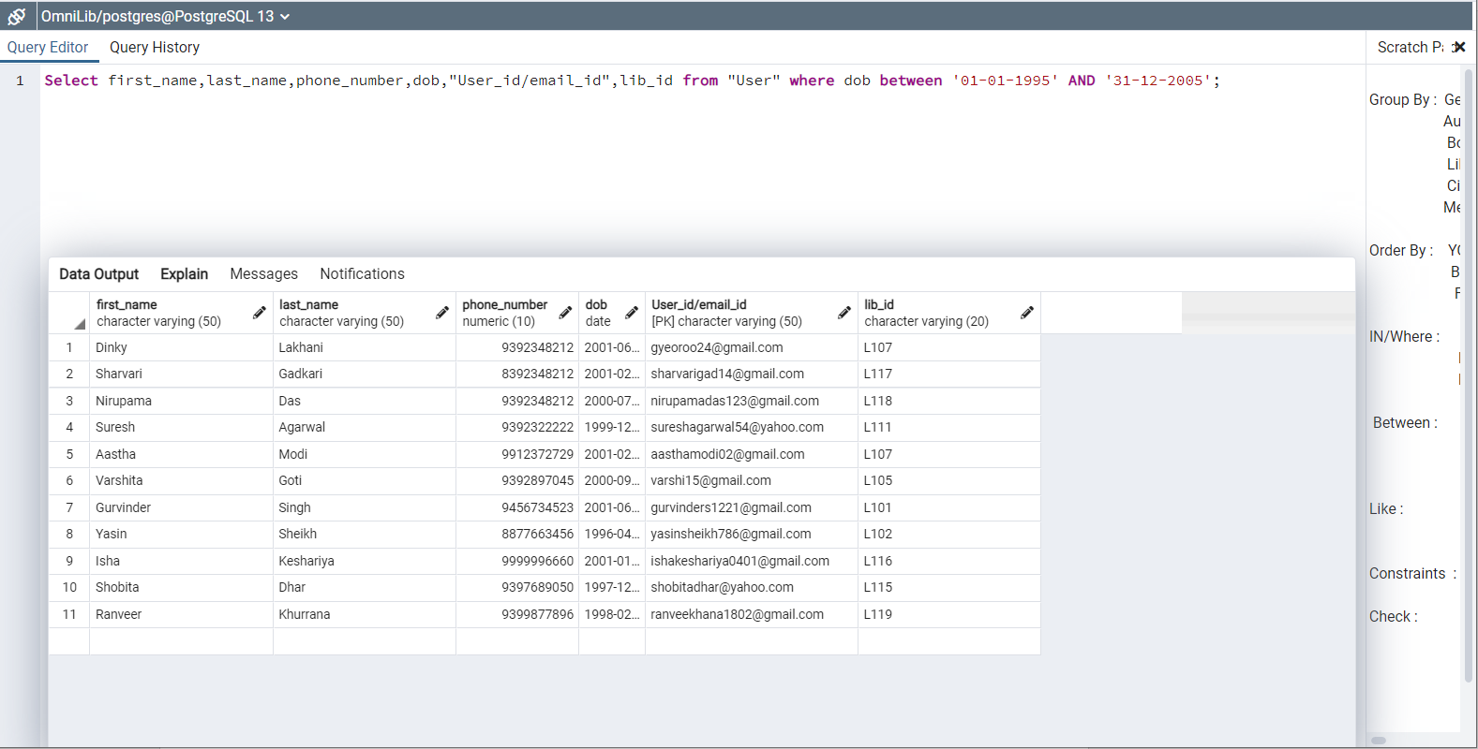

**6) Select distinct(author_name),gender from author where author_name like 'S%' ;**

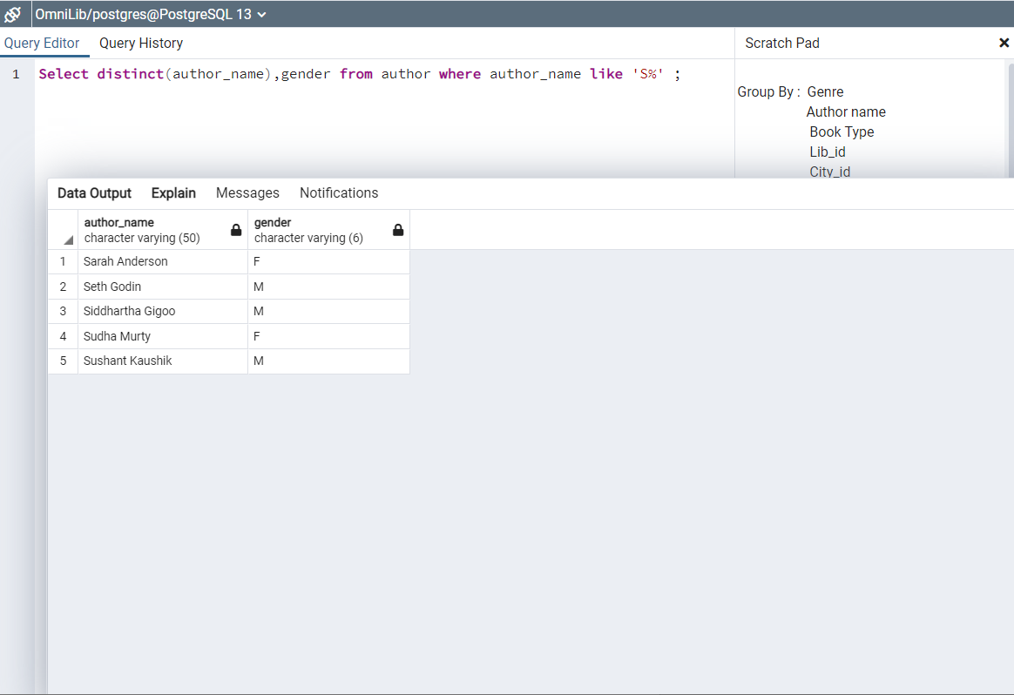

**7) Alter table "Merits/demerits" add constraint check_merit CHECK(rating between 0.0 AND 5.0);**

**Insert into "Merits/demerits" values**

**(-1.5,'vrajmodi11@gmail.com','gyeoroo24@gmail.com');**

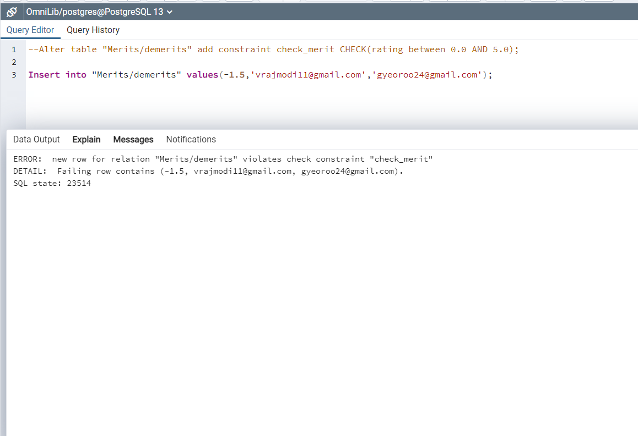

**Insert into "Merits/demerits" values (1.5,'vrajmodi11@gmail.com','gyeoroo24@gmail.com');**

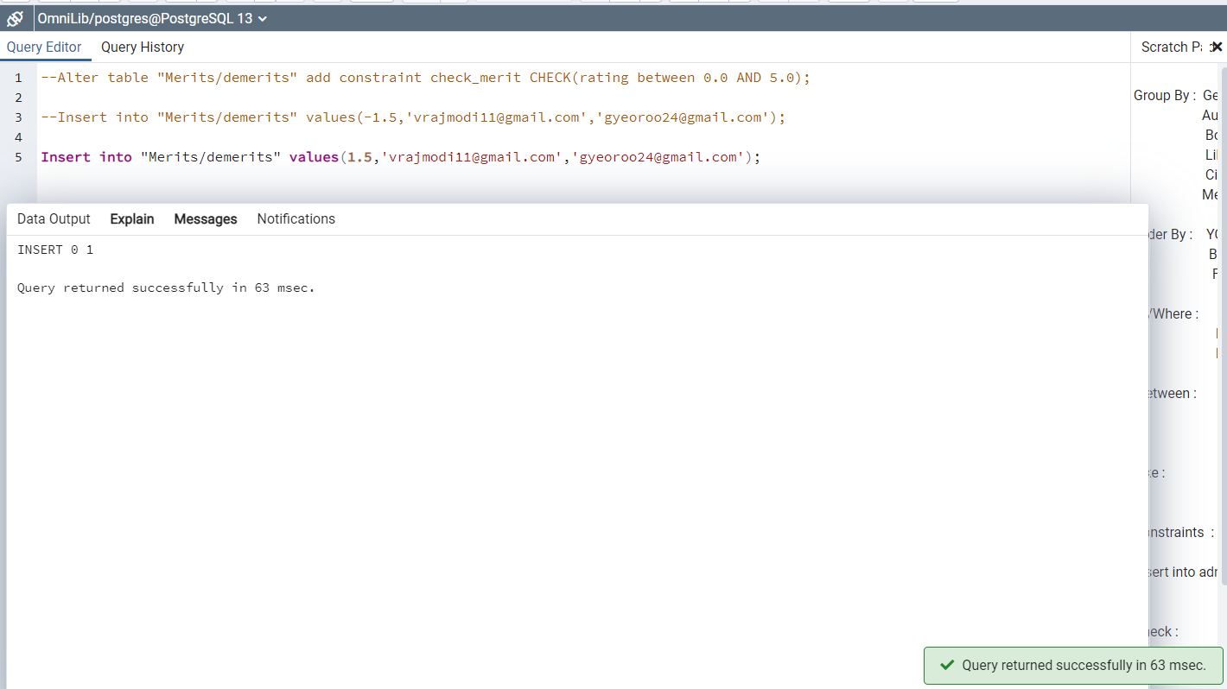

**8) Alter table "admin" add constraint check_email CHECK("User_id/email_id" LIKE '%@%.%');**

**Insert into admin values ('ashvathama1234.com','L101','V36','Ashvathama','Yadav',9382942333,'ksdflnskna','Admin Assistant','21-03-2001');**



